**Project Design Phase-II**

**Data Flow Diagram & User Stories**

|  |  |
| --- | --- |
| Date | 03 October 2023 |
| Team ID | NM2023TMID03082 |
| Project Name | Unleashing the Potential of Our Youth: A Student Performance Analysis |

**Data Flow Diagrams:**

A Data Flow Diagram (DFD) is a traditional visual representation of the information flows within a system. A neat and clear DFD can depict the right amount of the system requirement graphically. It shows how data enters and leaves the system, what changes the information, and where data is stored.



DFD LEVEL 0(Industry STANDARD)

[**(Simplified)**](https://developer.ibm.com/patterns/visualize-unstructured-text/) **DFD**

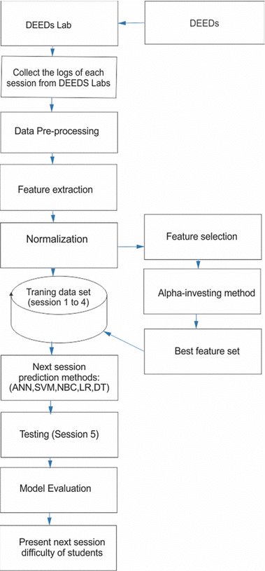

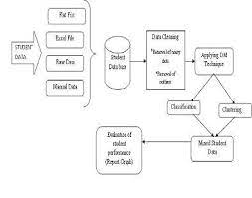

**User Stories**

Use the below template to list all the user stories for the product.

| **User Type** | **Functional Requirement (Epic)** | **User Story Number** | **User Story / Task** | **Acceptance criteria** | **Priority** | **Team Member** |
| --- | --- | --- | --- | --- | --- | --- |
| Teacher | Data Visualisation | USN-1 | As a teacher, He/ She wants to view a summary dashboard of his/her students' performance. | 1)The dashboard should display the overall class performance.  2)It should show the average scores for assignments, quizzes, and exams.  3)I should be able to filter the dashboard by class and date range.  4)The data on the dashboard should update in real-time. | High | Front-End Developer |
| Administrator | Analysis Insights | USN-2 | Generate performance reports for specific classes. | 1)Should be able to select a class and a date range for the report.  2)The report should include attendance, assignment, quiz, and exam scores for each student in the selected class.  3)Can export the report in PDF format. | Medium | Back-End Developer |
| Parent | Student Performance Analysis | USN-3 | As a parent, I want to receive push notifications on my mobile device for urgent performance-related updates. | 1)I can enable push notifications for low grades, missed assignments, or exceptional achievements.  2)Notifications should be sent in real-time and should include brief details.  3)I can customize the types of notifications I want to receive. | Low | Mobile App Developer |
| Administrator | Predictive Analysis | USN-4 | As an administrator, I want predictive analytics feature to identify students at risk of falling behind. | 1)The system analyses historical data to predict future performance.  2)Students at risk are highlighted based on attendance patterns, grades, and participation.  3)The system provides suggestions for intervention strategies. | High | Data Scientist |
| Student | Data Design | USN-5 | As a student, I want to access a personalized performance report to track my progress. | The report should include my grades, attendance records, and suggestions for improvement. It should be accessible from my student account. | High | UI/UX Designer |
| Administrator | User Management | USN-6 | As an administrator, I want to have the ability to add, remove, or edit student and teacher accounts. | Ability to create, update, or deactivate user accounts, ensuring data security and access control. | High | System Administrator |
| Parent | Parental Access | USN-7 | As a parent, I want to access my child's performance data in a secure and convenient manner. | Ability to log in to a parent portal and view my child's grades, attendance, and comments from teachers. Data should be protected with appropriate security measures. | Medium | Front-End Developer |